How to network like a Pro: Follow these LinkedIn Networking Tips

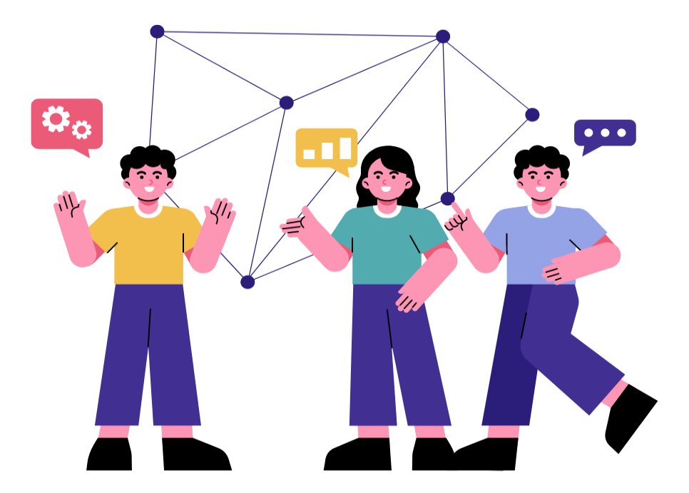

LinkedIn has been changing lives right from its inception in 2002. At the start of its journey, LinkedIn focused on growing its user base & expanding a few of its features like profile creation, connecting with professionals, job listing & group discussions.

But as the platform progressed forward, it started adding new features & improvements to the algorithm. With a focus on enhancing the mobile experience, acquiring LinkedIn Learning & integrating native video sharing, the platform evolved significantly. At present, LinkedIn is focusing on content creators & allows users to optimize their profile & provides tools for the same.

Throughout LinkedIn’s evolution for networking, it has remained committed to its mission of connecting professionals & facilitating career growth & development. It continues to adapt to the changing needs of its users & the broader professional landscape.

Are you on LinkedIn? Then this blog is just for you. In this article, we will delve into the world of networking & have a look at the advanced LinkedIn networking strategies you can use to grow yourself personally & professionally on LinkedIn. Ready to get started?

The Top 8 Networking Strategies
Set your Aim
This is the first & the most important step of being on LinkedIn. Aims or goals can help you scale your progress, stay focused & make the most out of the platform. Hence, your goals must be Specific, Measurable, Attainable, Relevant & Time Bound (SMART).

Your goals can range from attracting new clients to finding & hiring employees. Measuring goals through key metrics like post engagement or leads generated can help you stay on track.

Optimize your profile
Your LinkedIn profile should be complete, updated & optimized to attract your target audience. A well optimized profile can help you build your online presence along with your professional brand attracting the right opportunities & connections.

Optimizing your personal brand might seem overwhelming. For this, you can make the best use of tools available on the internet which optimize your profile to the ultimate level & help you reach your goals. PaintMinds is one such tool. Visit the Paintminds website to know more about how we can help you.

Build connections
Building connections on LinkedIn is essential for expanding your professional network, accessing opportunities, & advancing your career. LinkedIn is filled with users who may belong to the same industry as you.

Connecting with them will help you build yourself professionally. Networking on LinkedIn takes time & consistency. Therefore, it is important to dedicate regular time to engage with your network, nurture relationships & expand your connections.

Engagement is the key
Building connections & optimizing your profile alone cannot help you reach your LinkedIn goals. Networking is all about building relationships & to do that you must explore ways to engage with your audience.

Sharing relevant content, likes & comments can help you initiate conversations & engage authentically with your audience.

LinkedIn groups
LinkedIn groups are a great place to connect with users who have similar interests & belong to the same industry.

By actively participating in LinkedIn groups, you can expand your professional network, stay informed about industry trends, & establish yourself as a knowledgeable & engaged member of your professional community.

LinkedIn features
LinkedIn offers great tools for networking like LinkedIn Live, LinkedIn events, LinkedIn Learning, etc. All these tools can help you manage your profile to the optimum level & gain maximum exposure to growing professionally.

The platform continues to evolve & introduce new features to meet the needs of its users & enhances the professional networking experience.

Attend virtual events
Attending virtual events on LinkedIn is a great way to network with your audience. This gives you greater exposure to people belonging to your industry. LinkedIn Events facilitates engagement & networking among event attendees before, during, & after the event.

Users can engage with event organizers & fellow attendees by commenting on event posts, sharing insights, asking questions, & connecting with other attendees. LinkedIn Events provides a platform for professionals to connect, share knowledge, & build relationships within their industry or niche.

Follow up
Following up is a critical aspect of professional LinkedIn networking & professional communication, whether it is after a networking event, job interview, or initial connection on LinkedIn. Following up is a proven way to stay on top of your competitors.

Whether your goal is a job search or hiring employees, following up can show that you are genuinely interested in them. You can stand a greater chance of showcasing your personal brand.

Conclusion
The above LinkedIn Networking tips can help you grow strategically. By following all of them, you will be networking like a pro & expanding your reach. Happy professional networking on LinkedIn!

Keywords: LinkedIn networking tips | Professional networking on LinkedIn | LinkedIn evolution for networking | Advanced LinkedIn networking strategies | Networking like a pro on LinkedIn

Title Tag: LinkedIn Networking Tips that can transform you into a Pro.
Meta Description: Networking is all about building relationships. But how can you build valuable connections that offer great results. Read this article to know more.
Meta Tag: All you need to know about networking | PaintMinds

